Aeneid Book XI
Lines 1-224, 498-521, 532-596, 648-689, 725-835

Oceanum interea surgens Aurora reliquit:
Meanwhile Aurora, arising, left Oceanus:
Aeneas, quamquam et sociis dare tempus humandis
Aeneas – although to give time also to burying his comrades
praecipitant curae turbataque funere mens est,
do his cares hasten him and his mind is disturbed by their funeral –
vota deum primo victor solvebat Eoo.
was, as the victor, paying his vows made to the gods at the first (sign of) Eous.
ingentem quercum decisis undique ramis 5
A huge oak, with its branches lopped all round,
constituit tumulo fulgentiaque induit arma,
does he set up on a mound and decks out with the gleaming armour,
Mezenti ducis exuvias, tibi, magne, tropaeum
the spoils of the leader Mezentius, as a trophy to thee, O great one,
bellipotens; aptat rorantes sanguine cristas
O bellipotent one; he fastens (thereto) the plumes bedewed with blood,
telaque trunca viri, et bis sex thoraca petitum
and the man’s mutilated weapons, and the breastplate in twice six places
perfossumque locis, clipeumque ex aere sinistrae 10
targeted and pierced; and the shield of bronze to the (oak’s) left side
subligat atque ensem collo suspendit eburnum.
does he bind, and the ivory sword he suspends from the (oak’s) neck.

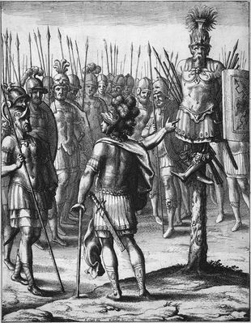

tum socios (namque omnis eum stipata tegebat
Then his exultant comrades – for the whole packed throng of leaders
turba ducum) sic incipiens hortatur ovantes:
enclosed him – beginning thus does he exhort:
‘maxima res effecta, viri; timor omnis abesto,
‘A very great deed has been accomplished, men. Away with all fear
quod superest; haec sunt spolia et de rege superbo 15
as to what remains! These are the spoils and first fruits from a proud king,
primitiae, manibusque meis Mezentius hic est.
and here by my hands is Mezentius!
nunc iter ad regem nobis murosque Latinos.
Now we have to make a march upon the king and the Latin walls!
arma parate, animis et spe praesumite bellum,
Prepare (your) weapons; with high spirits and hope anticipate this war,
ne qua mora ignaros, ubi primum vellere signa
lest any delay impede the ignorant, as soon as the powers above should give the nod
adnuerint superi pubemque educere castris, 20
to pluck up our standards and lead our adult men out of the camp,
impediat segnisve metu sententia tardet.
or (lest any) sluggish sentiments retard (us) by fear.
interea socios inhumataque corpora terrae
Meanwhile let us commit our comrades and their unburied bodies to the earth,
mandemus, qui solus honos Acheronte sub imo est.
which is the only honour (that counts) below in deepest Acheron.
ite’ ait, ‘egregias animas, quae sanguine nobis
Go’, says he, ‘(Those) outstanding spirits, who with their own blood have for us
hanc patriam peperere suo, decorate supremis 25
procured this homeland, do ye honour with the last
muneribus, maestamque Evandri primus ad urbem
rites, and first to Evander’s mourning city
mittatur Pallas, quem non virtutis egentem
let Pallas be sent, whom though not wanting in courage
abstulit atra dies et funere mersit acerbo.’
a black day has stolen and engulfed in bitter death.’

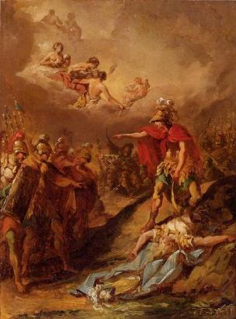

sic ait inlacrimans, recipitque ad limina gressum
Thus speaks he weeping, and he retraces his steps to an entrance
corpus ubi exanimi positum Pallantis Acoetes 30
where Acoetes was guarding the laid-out body of lifeless Pallas,
servabat senior, qui Parrhasio Evandro
(Acoetes) the elder, who to Parrhasian Evander
armiger ante fuit, sed non felicibus aeque
was formerly the armour-bearer, but who, under not equally felicitous
tum comes auspiciis caro datus ibat alumno.
auspices, then travelled as the appointed companion to his beloved child.
circum omnis famulumque manus Troianaque turba
Around (stand) the whole band of attendants, and the Trojan throng,
et maestum Iliades crinem de more solutae. 35
and the Trojan women, their mournful hair untied as per the custom.

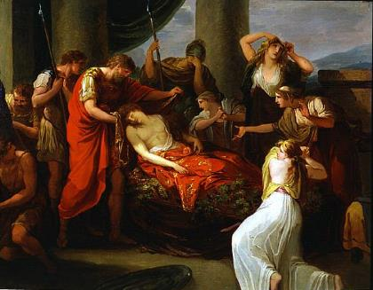

ut vero Aeneas foribus sese intulit altis
But when Aeneas betook himself within the lofty portals,
ingentem gemitum tunsis ad sidera tollunt
a huge groan do they raise to the stars with beaten
pectoribus, maestoque immugit regia luctu.
breasts, and with mournful grief does the royal tent bellow.
ipse caput nivei fultum Pallantis et ora
As for himself, when he saw the propped-up head and face of snow-white Pallas
ut vidit levique patens in pectore vulnus 40
and lying open in his smooth chest the wound
cuspidis Ausoniae, lacrimis ita fatur obortis:
made by an Ausonian spear, with welling tears does he speak:
‘tene, inquit, miserande puer, cum laeta veniret,
‘Was it thee’, he said, ‘O pitiable boy, that Fortune, when joyously she came,
invidit Fortuna mihi, ne regna videres
begrudged to me, lest thou should see that kingdom
nostra neque ad sedes victor veherere paternas?
of ours and lest thou be borne victorious to thy paternal home?
non haec Evandro de te promissa parenti 45
It was not such promises to thy father Evander about thee
discedens dederam, cum me complexus euntem
that I had given whilst leaving, when, embracing me as I was going,
mitteret in magnum imperium metuensque moneret
he sent (me) against a mighty power and in fear did warn
acres esse viros, cum dura proelia gente.
that (those) men were fierce, that the battle was with a hardy race.
et nunc ille quidem spe multum captus inani
And now he [Evander], much taken with vain hope,
fors et vota facit cumulatque altaria donis, 50
perchance makes even prayers and heaps the altars with his gifts,
nos iuvenem exanimum et nil iam caelestibus ullis
(while) we (this) youth, lifeless and nothing now to any in heaven
debentem vano maesti comitamur honore.
owing, do sorrowfully accompany with our vain honour.
infelix, nati funus crudele videbis!
O unhappy man, a son’s cruel funeral wilt thou see!
hi nostri reditus exspectatique triumphi?
Was this to be our expected return and triumph?
haec mea magna fides? at non, Evandre, pudendis 55
Was this my great pledge? Yet not, O Evander, with shameful
vulneribus pulsum aspicies, nec sospite dirum
wounds wilt thou behold him stricken, nor because of an unscathed son
optabis nato funus pater. hei mihi quantum
wilt thou his father desire dire death. Ah me, how great
praesidium, Ausonia, et quantum tu perdis, Iule!’
a bulwark thou, Ausonia, dost lose, and how great thou (too), O Iulus!’

haec ubi deflevit, tolli miserabile corpus
When he had bewept these things, the piteous corpse to be lifted
imperat, et toto lectos ex agmine mittit 60
does he command, and he despatches, selected from his whole army,
mille viros qui supremum comitentur honorem
one thousand men to accompany the final honour
intersintque patris lacrimis, solacia luctus
and to take part in the father’s tears, a solace for grief
exigua ingentis, misero sed debita patri.
meagre for (a grief) so huge, but owed to the heartbroken father.
haud segnes alii crates et molle feretrum
Not slothfully do others weave wickerwork and a bier soft
arbuteis texunt virgis et vimine querno 65
with arbutus branches and switches of oak,
exstructosque toros obtentu frondis inumbrant.
and the constructed couch with a canopy of leaf do they shade.
hic iuvenem agresti sublimem stramine ponunt:
Here the youth, high on the rustic straw, do they place:
qualem virgineo demessum pollice florem
like a flower reaped by virgin thumb,
seu mollis violae seu languentis hyacinthi,
whether (it be) of the tender violet or languid hyacinth,
cui neque fulgor adhuc nec dum sua forma recessit, 70
wherefrom neither still its sheen nor yet its beauty have withdrawn,
non iam mater alit tellus viresque ministrat.
whereto mother earth no more gives nourishment or ministers her strength.

tum geminas vestes auroque ostroque rigentes
Then twin robes, stiff with gold and purple,
extulit Aeneas, quas illi laeta laborum
did Aeneas bring out, which for him, joyful in her labours,
ipsa suis quondam manibus Sidonia Dido
had Sidonian Dido herself with her own hands once
fecerat et tenui telas discreverat auro. 75
made and with fine gold had separated the warp.
harum unam iuveni supremum maestus honorem
One of these on the youth as a final honour sadly
induit arsurasque comas obnubit amictu,
puts he on, and his soon-to-be-burned locks does he veil with a wrap,
multaque praeterea Laurentis praemia pugnae
and in addition many prizes of the Laurentian battle
aggerat et longo praedam iubet ordine duci;
piles he up, and he orders the booty to be conducted in a long procession;
addit equos et tela quibus spoliaverat hostem. 80
he adds the horses and weapons of which he had despoiled the enemy.
vinxerat et post terga manus, quos mitteret umbris
And he had bound behind their backs the hands (of those) whom he was send to the shades
inferias, caeso sparsurus sanguine flammas,
as funeral offerings, intending to sprinkle the flames with their slain blood,
indutosque iubet truncos hostilibus armis
and as for the tree-trunks clothed with enemy weapons, (these) he bids
ipsos ferre duces inimicaque nomina figi.
the leaders themselves to bear and that the foes’ names be affixed (thereto).

ducitur infelix aevo confectus Acoetes, 85
Led along, unhappy (and) worn out with (old) age, is Acoetes,
pectora nunc foedans pugnis, nunc unguibus ora.
now marring his breast with his fists, now his face with his nails,
sternitur et toto proiectus corpore terrae.
He is laid low, flung forward with his whole body on the earth.
ducunt et Rutulo perfusos sanguine currus.
And they lead the chariots bespattered with Rutulian blood.
post bellator equus positis insignibus Aethon
Behind (these) the warrior horse Aethon, his trappings laid aside,
it lacrimans guttisque umectat grandibus ora. 90
goes weeping and with large tear-drops wets his face.
hastam alii galeamque ferunt, nam cetera Turnus
Some carry (Pallas’) spear and helmet, for the remaining (weapons) does Turnus
victor habet. tum maesta phalanx Teucrique sequuntur
the victor hold. Then the mournful phalanx and the Teucrians follow,
Tyrrhenique omnes et versis Arcades armis.
and all the Tyrrhenians and Arcadians with their weapons inverted.

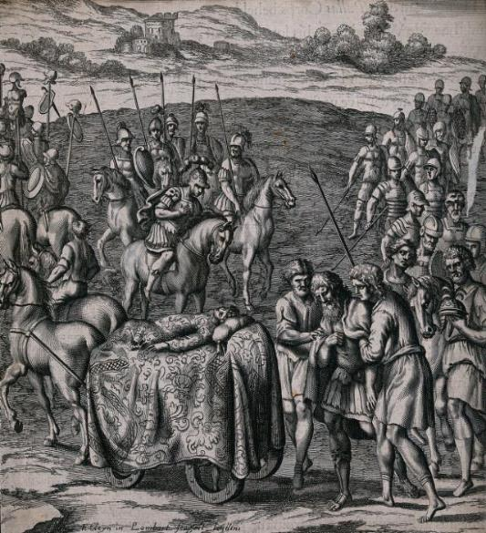

postquam omnis longe comitum praecesserat ordo,
After the whole line of his comrades had gone ahead a good distance,
substitit Aeneas gemituque haec addidit alto: 95
Aeneas halted and with a deep sigh added these (words):
‘nos alias hinc ad lacrimas eadem horrida belli
‘As for us, hence to other tears do the same rough fates of war
fata vocant: salve aeternum mihi, maxime Palla,
call us. Hail for ever from me, O truly great Pallas,
aeternumque vale.’ nec plura effatus ad altos
and for ever farewell!’ And uttering no more, unto the high
tendebat muros gressumque in castra ferebat.
walls did he head, and his steps into the camp did he bear.

iamque oratores aderant ex urbe Latina 100
And now spokesmen were at hand from the Latin city
velati ramis oleae veniamque rogantes:
veiled in branches of olive and requesting a favour:
corpora, per campos ferro quae fusa iacebant,
that the bodies which lay strewn by the sword through the fields
redderet ac tumulo sineret succedere terrae;
he might return and allow to go below a mound of earth;
nullum cum victis certamen et aethere cassis;
there was no quarrel with the vanquished and those deprived of the aether;
parceret hospitibus quondam socerisque vocatis. 105
let him spare his one-time hosts and and those called father-in-laws.
quos bonus Aeneas haud aspernanda precantes
These men entreating things not to be spurned does goodly Aeneas
prosequitur venia et verbis haec insuper addit:
honour with indulgence, and to his words he also adds these:
‘quaenam vos tanto fortuna indigna, Latini,
‘What shameful fortune entangled you, O Latins,
implicuit bello, qui nos fugiatis amicos?
in so great a war, that ye should fly from us your friends?
pacem me exanimis et Martis sorte peremptis 110
Is it peace for the lifeless and those taken off by the lottery of Mars
oratis? equidem et vivis concedere vellem.
that ye beg of me? For my part, to the living also would I grant it!
nec veni, nisi fata locum sedemque dedissent,
I would not have come had not the fates granted (me) a site and a home,
nec bellum cum gente gero; rex nostra reliquit
nor is it war with (your) people that I wage; ‘twas the king that abandoned our
hospitia et Turni potius se credidit armis.
guest-friendship and entrusted himself rather to Turnus’ weapons.
aequius huic Turnum fuerat se opponere morti. 115
Juster had it been for Turnus to face death of this kind!
si bellum finire manu, si pellere Teucros
If it is to finish this war by main-force, if it is to drive out the Teucrians,
apparat, his mecum decuit concurrere telis:
that he prepares, then with me ought he to have contended with these weapons:
vixet cui vitam deus aut sua dextra dedisset.
(Then) would have lived he to whom god or his own right hand allowed.
nunc ite et miseris supponite civibus ignem.’
Now go ye and under your wretched citizens place fire!’

dixerat Aeneas. illi obstipuere silentes 120
Aeneas had spoken. Those men were struck dumb in silence,
conversique oculos inter se atque ora tenebant.
and turning round they held their eyes and faces on one another.
tum senior semperque odiis et crimine Drances
Then Drances, an elderly man and one in hatred and accusation ever
infensus iuveni Turno sic ore vicissim
hostile to the youth Turnus, thus in turn with his mouth
orsa refert: ‘o fama ingens, ingentior armis,
responds (with these) undertakings: ‘O great in fame, greater (still) in arms,
vir Troiane, quibus caelo te laudibus aequem? 125
O Trojan man, with what praises might I raise thee level to the heavens!
iustitiaene prius mirer belline laborum?
Should I admire thee first for (thy) justice or (thy) exertions in war?
nos vero haec patriam grati referemus ad urbem
We for our part will gratefully report these things to our native city,
et te, si qua viam dederit Fortuna, Latino
and thee, if somehow Fortune should grant a way, unto king Latinus
iungemus regi. quaerat sibi foedera Turnus.
will we unite. Let Turnus seek treaties for himself!
quin et fatales murorum attollere moles 130
Nay, even to raise up the destined masses of the walls,
saxaque subvectare umeris Troiana iuvabit.’
and to carry up on (our) shoulders Trojan rocks will be a pleasure!’
dixerat haec unoque omnes eadem ore fremebant.
These things had he spoken, and with one mouth all were murmuring the same.

bis senos pepigere dies, et pace sequestra
For twice six days made they a pact, and with peace as their guarantor
per silvas Teucri mixtique impune Latini
through the woods with impunity did Teucrians and Latins intermixed
erravere iugis. ferro sonat alta bipenni 135
wander on the ridges. With two-winged iron resounds the high
fraxinus, evertunt actas ad sidera pinus,
ash, they overturn pines driven (up) to the stars,
robora nec cuneis et olentem scindere cedrum
nor cease they with wedges to cleave oaks and the fragrant cedar,
nec plaustris cessant vectare gementibus ornos.
nor on groaning carts to transport mountain ashes.

et iam Fama volans, tanti praenuntia luctus,
And now Rumour in her flight, the harbinger of such a mighty grief,
Evandrum Evandrique domos et moenia replet, 140
fills Evander and Evander’s home and walls (with her news),
quae modo victorem Latio Pallanta ferebat.
(she) who a moment ago reported Pallas victorious in Latium.
Arcades ad portas ruere et de more vetusto
Arcadians rushed to the gates and as per ancient custom
funereas rapuere faces; lucet via longo
snatched up funerary torches; the road glitters with a long
ordine flammarum et late discriminat agros.
line of flames, and widely picks it out the fields.
contra turba Phrygum veniens plangentia iungit 145
The troop of Phrygyians coming to meet them joins the plangent
agmina. quae postquam matres succedere tectis
columns. After mothers had seen them coming up to their houses,
viderunt, maestam incendunt clamoribus urbem.
they set the mournful city ablaze with their clamours.
at non Evandrum potis est vis ulla tenere,
But no force is capable of holding Evander (back),
sed venit in medios. feretro Pallanta reposto
but comes he into their midst. With the bier set down, over Pallas
procubuit super atque haeret lacrimansque gemensque, 150
did he stoop, and he clings (to him) weeping and groaning,
et via vix tandem voci laxata dolore est:
and scarcely at last was a way eased open to his voice by his grief:

‘Non haec, O Palla, dederas promissa parenti,
‘Not such, O Pallas, were the promises thou hadst given thy father,
cautius ut saevo velles te credere Marti.
that cautiously wouldst thou trust thyself to savage Mars.
haud ignarus eram quantum nova gloria in armis
Not ignorant was I how influential fresh glory in arms
et praedulce decus primo certamine posset. 155
and most sweet honour in a first conflict can be.
primitiae iuvenis miserae bellique propinqui
Ah, the wretched first-fruits of youth, of a nearby war’s
dura rudimenta, et nulli exaudita deorum
harsh novitiate, and, heeded by none of the gods,
vota precesque meae! tuque, O sanctissima coniunx,
my own vows and prayers! And thou, O my most holy wife,
felix morte tua neque in hunc servata dolorem!
happy art thou in thy death and that thou wast not kept (alive) for this sorrow!
contra ego vivendo vici mea fata, superstes 160
I, on the other hand, by living on, have conquered my fates, to remain
restarem ut genitor. Troum socia arma secutum
his surviving parent. (As for me) who followed the allied arms of the Trojans,
obruerent Rutuli telis! animam ipse dedissem
would that the Rutulians were overwhelming (me) with their weapons. I myself would have given (my) life,
atque haec pompa domum me, non Pallanta, referret!
and (then) this procession would be bearing me back home, not Pallas!
nec vos arguerim, Teucri, nec foedera nec quas
nor would I blame you, O Teucrians, nor our treaty nor
iunximus hospitio dextras: sors ista senectae 165
the right hands we joined in guest-friendship: (for) this fate to our old age
debita erat nostrae. quod si immatura manebat
was due. But if it was a premature death that awaited my son,
mors gnatum, caesis Volscorum milibus ante
then will it help (to know) that, when thousands of Volsci had first been cut down,
ducentem in Latium Teucros cecidisse iuvabit.
he fell whilst leading the Teucrians into Latium.
quin ego non alio digner te funere, Palla,
Nay, of no other funeral would I deem thee worthy, Pallas,
quam pius Aeneas et quam magni Phryges et quam 170
than that which dutiful Aeneas and that which the mighty Phrygians and that which
Tyrrhenique duces, Tyrrhenum exercitus omnis.
the Tyrrhenian leaders, the whole army of Tyrrhenians (are performing).
magna tropaea ferunt quos dat tua dextera leto;
Great trophies they bear (of those) whom thy right hand gives to death.
tu quoque nunc stares immanis truncus in armis,
Thou too wouldst now be standing a monstrous tree-trunk in arms,
esset par aetas et idem si robur ab annis,
were his age the equal and the strength of his years the same (as thine),
Turne. sed infelix Teucros quid demoror armis? 175
O Turnus. But why do I, unhappy man, detain you Teucrians from battle?
vadite et haec memores regi mandata referte:
Go and mindfully carry back this commission to your king:
quod vitam moror invisam Pallante perempto
that I prolong (my) hated life now that Pallas has been taken off,
dextera causa tua est, Turnum gnatoque patrique
the reason is thy right hand, which thou seest to owe
quam debere vides. meritis vacat hic tibi solus
Turnus to both son and father. This is the only avenue open to thee
fortunaeque locus. non vitae gaudia quaero, 180
for merit and (good) fortune. It is not the joys of life that I seek,
nec fas, sed gnato manes perferre sub imos.’
– that would not be right – but to bring such to my son beneath the deepest shades.’

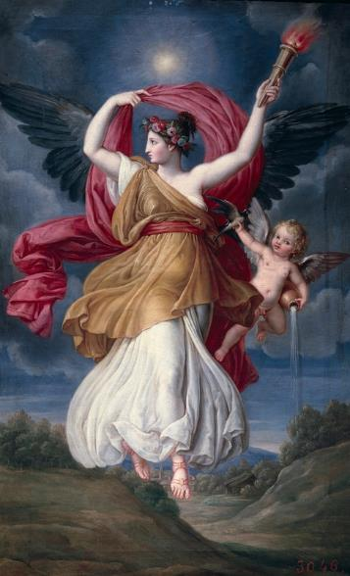

Aurora interea miseris mortalibus almam
Aurora meanwhile had for wretched mortals brought out
extulerat lucem referens opera atque labores:
the nourishing light, bringing back (their) work and toil:
iam pater Aeneas, iam curvo in litore Tarchon
now Father Aeneas, now Tarchon, on the winding shore
constituere pyras. huc corpora quisque suorum 185
did set up pyres. Hither each brought the bodies of their people
more tulere patrum, subiectisque ignibus atris
according to their fathers’ custom, and black fires having been set beneath (them),
conditur in tenebras altum caligine caelum.
the sky is buried deep in darkness by the smoke.
ter circum accensos cincti fulgentibus armis
Thrice around the enkindled pyres, girded in their gleaming arms,
decurrere rogos, ter maestum funeris ignem
did they parade; thrice the mournful fire of the funeral
lustravere in equis ululatusque ore dedere. 190
did they circle on horses, and from their mouth they gave out wails.
spargitur et tellus lacrimis, sparguntur et arma,
And besprinkled is the earth with their tears, and besprinkled their armour;
it caelo clamorque virum clangorque tubarum.
up to the heavens go both the clamour of men and the blare of trumpets.
hic alii spolia occisis derepta Latinis
At this point some fling spoils snatched from the slain Latins
coniciunt igni, galeas ensesque decoros
on the fire: helmets and ornate swords
frenaque ferventesque rotas; pars munera nota, 195
and bridles and fervid wheels; others (fling) familiar offerings,
ipsorum clipeos et non felicia tela.
the shields of the men themselves and their unlucky weapons.
multa boum circa mactantur corpora Morti,
Around about, many bodies of cattle are immolated to Death,
saetigerosque sues raptasque ex omnibus agris
and bristle-bearing boars and livestock seized from all the fields
in flammam iugulant pecudes. tum litore toto
do they jugulate into the flame. Then throughout the whole shore
ardentes spectant socios semustaque servant 200
they behold their comrades burn, and they watch over the half-burned
busta, neque avelli possunt, nox umida donec
pyres, nor can they be torn away, until moist night
invertit caelum stellis ardentibus aptum.
inverts the vault of heaven fitted with its blazing stars.

Nec minus et miseri diversa in parte Latini
No less did the wretched Latins too in a different part
innumeras struxere pyras, et corpora partim
construct countless pyres, and some bury the many bodies
multa virum terrae infodiunt, avectaque partim 205
of (their) men in the earth, and some carry them, when carted off,
finitimos tollunt in agros urbique remittunt.
into neighbouring territory and send them back to their city.
cetera confusaeque ingentem caedis acervum
The remaining (bodies), a vast heap of confused slaughter,
nec numero nec honore cremant; tunc undique vasti
do they cremate with neither number nor honour; then on all sides the desolate
certatim crebris conlucent ignibus agri.
fields in rivalry shine bright with their flickering fires.

tertia lux gelidam caelo dimoverat umbram: 210
A third dawn had removed the chill shadow from the sky:
maerentes altum cinerem et confusa ruebant
grieving, they were raking the deep ash and the mingled
ossa focis tepidoque onerabant aggere terrae.
bones in the pyres, and weighing them down with a warm mound of earth.
iam vero in tectis, praedivitis urbe Latini,
Now indeed in (their) houses, in the city of opulent Latinus,
praecipuus fragor et longi pars maxima luctus.
(does) the chief din and main part of (their) long mourning (arise).
hic matres miseraeque nurus, hic cara sororum 215
Here mothers and their wretched daughters-in-law, here the loving
pectora maerentum puerique parentibus orbi
breasts of grieving sisters, and boys bereaved of their fathers,
dirum exsecrantur bellum Turnique hymenaeos;
do execrate the dreadful war and Turnus’ nuptials;
ipsum armis ipsumque iubent decernere ferro,
he himself with his arms, and he himself with the sword, do they bid decide (matters),
qui regnum Italiae et primos sibi poscat honores.
he who demands for himself the kingship of Italy and its foremost honours!
ingravat haec saevus Drances solumque vocari 220
The furious Drances weighs in on this, and attests that one alone is called,
testatur, solum posci in certamina Turnum.
one alone is challenged to combat – Turnus!
multa simul contra variis sententia dictis
At the same time, there is much contrary opinion in various utterances
pro Turno, et magnum reginae nomen obumbrat,
in favour of Turnus, and the queen’s great name shelters him;
multa virum meritis sustentat fama tropaeis.
great fame from trophies won upholds the man.

Latinus realizes he is fighting Fate in opposing Aeneas. This is confirmed by both the recent defeat of his men and the disappointing report of his envoys to the Grecian king Diomedes. Diomedes advises the Latins to make peace with the Trojans, for those who oppose them are punished by the gods. Latinus proposes either settling the Trojans on land of his own or else helping them build ships to sail elsewhere; he proposes to send a 100-man embassy to make peace terms. Drances seconds this, advising that the hand of Lavinia be offered in the deal; he blames Turnus for failing to engage in one-to-one combat with Aeneas, thus bringing needless war on their whole people. Turnus responds in anger, revealing his determination to continue the war. Their deliberations are interrupted by news of an impending attack. Turnus moves quickly to defend the city while the Queen and Lavinia repair to Minerva’s temple.

obvia cui Volscorum acie comitante Camilla
Coming to meet him, the battle array of the Volsci accompanying her, Camilla
occurrit portisque ab equo regina sub ipsis
ran up, and under the very gates themselves did the princess from her horse
desiluit, quam tota cohors imitata relictis 500
leap down, imitating whom the whole cohort, leaving
ad terram defluxit equis; tum talia fatur:
their horses, flowed down to the ground; then such things speaks she:
‘Turne, sui merito si qua est fiducia forti,
‘Turnus, if in any way self-confidence rightly belongs to the brave,
audeo et Aeneadum promitto occurrere turmae
I dare and promise to encounter the squadron of Aeneas’ men,
solaque Tyrrhenos equites ire obvia contra.
and alone to go up against the Tyrrhenian horsemen.
me sine prima manu temptare pericula belli, 505
Allow me to try (my) first perils of war in hand-to-hand combat,
tu pedes ad muros subsiste et moenia serva.’
(and) do thou stay on foot by the walls and guard the battlements.’

Turnus ad haec oculos horrenda in virgine fixus:
To this Turnus, fixing his eyes on the awesome maiden, (answers):
‘O decus Italiae virgo, quas dicere grates
‘O maiden, glory of Italy, what thanks should I prepare to utter
quasve referre parem? sed nunc, est omnia quando
or what (thanks) to repay? But now, since that spirit (of thine)
iste animus supra, mecum partire laborem. 510
is above all (bounds), share with me (this) toil.
Aeneas, ut fama fidem missique reportant
Aeneas, as rumour and despatched scouts bear back confirmation,
exploratores, equitum levia improbus arma
has sent forth – the scoundrel! – the light arms of his cavalry
praemisit, quaterent campos; ipse ardua montis
(with orders) to set the fields aquiver; he himself, coming up through the mountain’s
per deserta iugo superans adventat ad urbem.
deserted steeps by a ridge, approaches the city.
furta paro belli convexo in tramite silvae, 515
I am preparing the tricks of war in an arched path of the wood,
ut bivias armato obsidam milite fauces.
to blockade the two-way defile with armed soldiers.
tu Tyrrhenum equitem conlatis excipe signis;
Do thou intercept the Tyrrhenian cavalry with (thy) standards joined.
tecum acer Messapus erit turmaeque Latinae
With thee will be keen Messapus and the Latin squadrons
Tiburtique manus, ducis et tu concipe curam.’
and the contingent of Tiburtus; take thou on too a leader’s care.’
sic ait, et paribus Messapum in proelia dictis 520
Thus he speaks, and with like words he exhorts Messapus to battle
hortatur sociosque duces, et pergit in hostem.
and the allied leaders, and he proceeds against the enemy.

Turnus heads for the aforementioned defile and readies his ambush in a hidden plateau above.

velocem interea superis in sedibus Opim,
Meantime in the abodes above, swift Opis,
unam ex virginibus sociis sacraque caterva,
one of her companion maids and of her sacred band,
compellabat et has tristes Latonia voces
was Latona’s daughter addressing, and these sad words
ore dabat: ‘Graditur bellum ad crudele Camilla, 535
was she uttering from her mouth: ‘She goes to a cruel war does Camilla,
O virgo, et nostris nequiquam cingitur armis,
O maid, and in vain girds she herself with our weapons,
cara mihi ante alias. neque enim novus iste Dianae
though (she be) dear to me before all others. For not newly to Diana has this
venit amor subitaque animum dulcedine movit.
love come and moved her mind with sudden sweetness.
pulsus ob invidiam regno viresque superbas
Driven out from (his) kingdom owing to envy and his own arrogant strength,
Priverno antiqua Metabus cum excederet urbe, 540
Metabus, when he was departing from the ancient city (of) Privernum,
infantem fugiens media inter proelia belli
took up, as he fled, the infant in the very midst of war’s battles
sustulit exsilio comitem, matrisque vocavit
to be his companion in exile, and he called (her) after her mother
nomine Casmillae mutata parte Camillam.
Casmilla’s name, part having been changed, Camilla.
ipse sinu prae se portans iuga longa petebat
He himself, carrying (her) before him on his breast, made for a long ridge
solorum nemorum: tela undique saeva premebant 545
of solitary groves: fierce weapons from every side were pressing (him),
et circumfuso volitabant milite Volsci.
and the Volsci, their soldiers dispersed all around, were flying about.
ecce fugae medio summis Amasenus abundans
Lo, in the midst of his flight, the Amasenus, overflowing from its topmost
spumabat ripis, tantus se nubibus imber
banks, was foaming, such a great rainstorm from the clouds
ruperat. ille innare parans infantis amore
had burst. He, preparing to swim therein, out of love of the infant
tardatur caroque oneri timet. omnia secum 550
is slowed, and he fears for his beloved burden. To him turning over with himself all (options),
versanti subito vix haec sententia sedit:
suddenly yet with difficulty did this idea take root:
telum immane manu valida quod forte gerebat
the monstrous weapon that the warrior happened to be carrying in his stout hand,
bellator, solidum nodis et robore cocto,
(a weapon) solid with its knots and cooked oak,
huic natam libro et silvestri subere clausam
to this his daughter, enclosed in bark and forest cork,
implicat atque habilem mediae circumligat hastae; 555
does he entwine, and he binds her manageably to the midst of his spear;
quam dextra ingenti librans ita ad aethera fatur:
balancing this in his huge right hand, thus to the ether he speaks:
‘Alma, tibi hanc, nemorum cultrix, Latonia virgo,
‘O bountiful one, to thee this (child), O cultivator of the groves, virgin daughter of Latona,
ipse pater famulam voveo; tua prima per auras
do I myself her father vow as thy handmaid; thy suppliant through the air, her first
tela tenens supplex hostem fugit. accipe, testor,
weapon holding, flees the enemy. Accept, I adjure thee,
diva tuam, quae nunc dubiis committitur auris.’ 560
O goddess, thine own, who is now committed to the dubious breezes.’

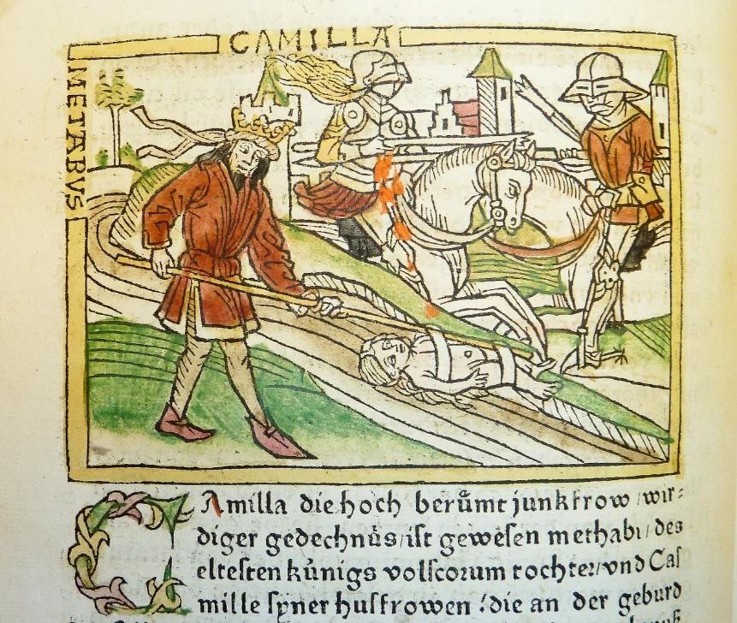

dixit, et adducto contortum hastile lacerto
He spoke, and with his upper arm drawn back, the twisted spear-shaft
immittit: sonuere undae, rapidum super amnem
he despatches: the waters roared, over the rapid river
infelix fugit in iaculo stridente Camilla.
flies the unhappy Camilla on the whistling javelin.
at Metabus magna propius iam urgente caterva
And now Metabus, a large troop now pressing him more closely,
dat sese fluvio, atque hastam cum virgine victor 565
commits himself to the stream, and the spear with the maid victoriously
gramineo, donum Triviae, de caespite vellit.
does he pluck from the grassy turf, his gift to Trivia.
non illum tectis ullae, non moenibus urbes
Not him in their houses, not him in their walls did any cities
accepere, neque ipse manus feritate dedisset,
receive, nor because of his fierceness would he have surrendered himself,
pastorum et solis exegit montibus aevum.
and he lived the life of shepherds on the lonely mountains.
hic natam in dumis interque horrentia lustra 570
Here his daughter, in the brambles and amidst bristling dens,
armentalis equae mammis et lacte ferino
from the teats and ferine milk of a herd-mare
nutribat teneris immulgens ubera labris.
did he nourish, milking its udders into her tender lips.
utque pedum primis infans vestigia plantis
And when the infant had, with the first (use of the) soles of her feet,
institerat, iaculo palmas armavit acuto
eagerly pursued tracks, then did he arm her palms with a sharp javelin,
spiculaque ex umero parvae suspendit et arcum. 575
and from the shoulder of the little girl he suspended darts and a bow.
pro crinali auro, pro longae tegmine pallae
Instead of gold for her hair, instead of the covering of a long mantle,
tigridis exuviae per dorsum a vertice pendent.
a tiger’s hide hangs from her head along her back.
tela manu iam tum tenera puerilia torsit
Already then did she brandish from her tender hand her childish weapons,
et fundam tereti circum caput egit habena
and a sling with a smooth thong did she whirl around her head,
Strymoniamque gruem aut album deiecit olorem. 580
and she felled the Strymonian crane or the white swan.
multae illam frustra Tyrrhena per oppida matres
In vain did many mothers throughout Tyrrenhian towns desire her
optavere nurum; sola contenta Diana
for their daughter-in-law; content with Diana alone,
aeternum telorum et virginitatis amorem
a lifelong love of (her) weapons and virginity
intemerata colit. vellem haud correpta fuisset
does the undefiled one cultivate. I would she had not been caught up
militia tali conata lacessere Teucros: 585
in such warfare, trying to challenge the Teucrians:
cara mihi comitumque foret nunc una mearum.
dear to me and now one of my companions would she be.
verum age, quandoquidem fatis urgetur acerbis,
But come now, seeing that she is urged on by bitter fates,
labere, nympha, polo finesque invise Latinos,
slip down, O nymph, from the heavens and look in on the Latin territory,
tristis ubi infausto committitur omine pugna.
where a gloomy battle is being joined under unfavourable auspices.
haec cape et ultricem pharetra deprome sagittam: 590
Take these (my weapons), and draw out from my quiver an avenging arrow:
hac, quicumque sacrum violarit vulnere corpus,
with this, whoever should violate her sacred body with a wound,
Tros Italusque, mihi pariter det sanguine poenas.
(be he) Trojan or Italian, may he likewise pay me the penalty in his blood.
post ego nube cava miserandae corpus et arma
Afterwards I, in a cavernous cloud, will bear the pitiful girl’s body and weapons
inspoliata feram tumulo patriaeque reponam.’
undespoiled to a tumulus and restore them to her fatherland.’
dixit, at illa leves caeli delapsa per auras 595
(So) she (Diana) spoke, and now she (Opis), slipping down through the light airs of the sky,
insonuit nigro circumdata turbine corpus.
whirred, surrounding her body in a black whirlwind.

The warring cavalries meet on the plain. Twice do theTrojans/Etruscans thrust the Latins/Volsci back to the walls of their town, twice are they repulsed by a counter-charge. But on the third occasion both sides stand their ground and blood flows thick.

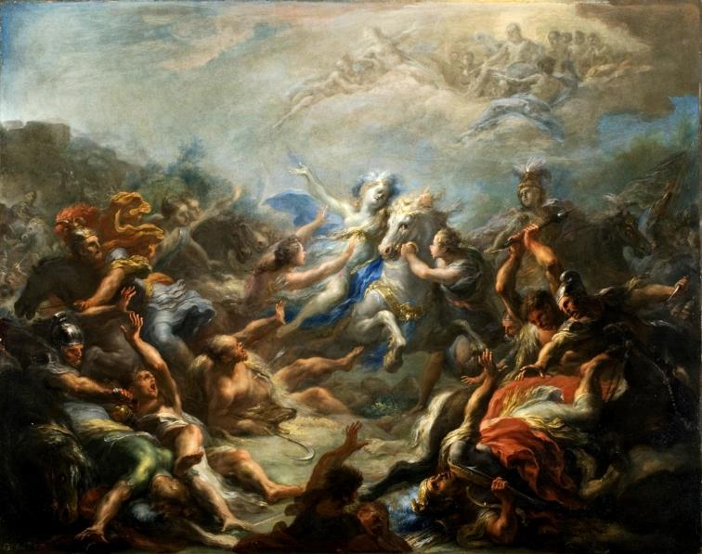

at medias inter caedes exsultat Amazon
And now, in the very midst of the slaughter, an Amazon exults,
unum exserta latus pugnae, pharetrata Camilla,
one side protruding for battle, quiver-bearing Camilla;
et nunc lenta manu spargens hastilia denset, 650
and now, scattering her supple shafts from her hand, she makes (them fly) thick,
nunc validam dextra rapit indefessa bipennem;
(and) now unwearied she snatches up with her right hand her stout battle-axe,
aureus ex umero sonat arcus et arma Dianae.
from her shoulder clangs a golden bow and the arms of Diana.
illa etiam, si quando in tergum pulsa recessit,
If ever driven back she retreated, she even
spicula converso fugientia derigit arcu.
directs her fleeing darts with her bow turned backwards.
at circum lectae comites, Larinaque virgo 655
And around are her choice companions, the maid Larina,
Tullaque, et aeratam quatiens Tarpeia securim,
and Tulla, and Tarpeia brandishing her bronzèd axe,
Italides, quas ipsa decus sibi dia Camilla
daughters of Italy, whom she, godlike Camilla, chose to be (a guard of) honour for herself
delegit pacisque bonas bellique ministras:
and to be goodly ministers in both peace and war:
quales Threiciae cum flumina Thermodontis
such are the Thracian Amazons when they pound the currents of Thermodon
pulsant et pictis bellantur Amazones armis, 660
and make war with their painted weapons,
seu circum Hippolyten seu cum se Martia curru
whether it be around Hippolyte, or else when Mars-born Penthesilea
Penthesilea refert, magnoque ululante tumultu
returns in her chariot, and with a great whooping tumult
feminea exsultant lunatis agmina peltis.
the female ranks exult with their moon-shaped shields.

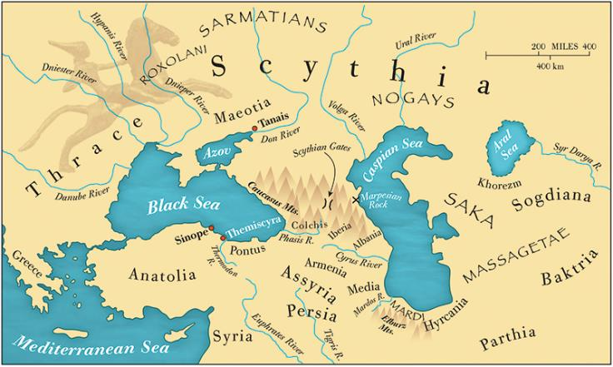

quem telo primum, quem postremum, aspera virgo,
Whom first with thy weapon, whom last, harsh maid,
deicis? aut quot humi morientia corpora fundis? 665
dost thou bring down? Or how many bodies dost thou strew dying on the ground?
Eunaeum Clytio primum patre, cuius apertum
T’was Eunaeus first – his father being Clytius – whose exposed chest,
adversi longa transverberat abiete pectus.
as he faced (her), she transfixes with her long fir-lance.
sanguinis ille vomens rivos cadit atque cruentam
Vomiting streams of blood he falls, and the blood-stained
mandit humum moriensque suo se in vulnere versat.
ground does he bite, and as he dies he turns upon his wound.
tum Lirim Pagasumque super, quorum alter habenas 670
Then Liris and Pagasus on top of him (she brings down): one of whom,
suffuso revolutus equo dum colligit, alter
whilst gathering his reins after rolling off his spreadeagled horse, the other,
dum subit ac dextram labenti tendit inermem,
whilst coming up and stretching an unarmed right hand to the falling man,
praecipites pariterque ruunt. his addit Amastrum
headlong and together come crashing down. To these she adds Amastrus,
Hippotaden, sequiturque incumbens eminus hasta
son of Hippotas, and pressing on she pursues at long range with her spear
Tereaque Harpalycumque et Demophoonta Chromimque; 675
Tereus and Harpalycus, and Demophoon and Chromis;
quotque emissa manu contorsit spicula virgo,
and as many the darts that, despatched from her hand, the maid hurled,
tot Phrygii cecidere viri. procul Ornytus armis
just so many Phrygian men fell. Some way off Ornytus, with armour
ignotis et equo venator Iapyge fertur,
unfamiliar and on a Iapygian horse, rides, a huntsman he,
cui pellis latos umeros erepta iuvenco
whose broad shoulders does a hide stripped from a combative bullock
pugnatori operit; caput ingens oris hiatus 680
cover; his head did the huge opening of the mouth
et malae texere lupi cum dentibus albis,
and jaws of a wolf along with its white teeth cover,
agrestisque manus armat sparus; ipse catervis
and a rustic hunting-spear arms his hands; amidst his troops
vertitur in mediis et toto vertice supra est.
does he move about, and above (them) by a full head is he.
hunc illa exceptum (neque enim labor agmine verso)
Having intercepted him – for no effort (was required) once the column had turned –
traicit et super haec inimico pectore fatur: 685
she pierces him through, and over him speaks these things with hostile breast:
‘Silvis te, Tyrrhene, feras agitare putasti?
‘Didst thou think, Tyrrenhian, thou wast bestirring wild creatures in the woods?
advenit qui vestra dies muliebribus armis
The day has arrived to refute your words with a woman’s arms.
verba redargueret. nomen tamen haud leve patrum
Yet no slight name is this that thou wilt report
manibus hoc referes, telo cecidisse Camillae.’
to (thy) fathers’ shades, (telling them) that thou fell by the spear of Camilla!’

Camilla continues her killing spree, killing Orsilochus and Butes, and even despatching the trickster son of Aunus by outpacing his horse on foot.

at non haec nullis hominum sator atque deorum 725
And now the Sower of men and of gods, these things not
observans oculis summo sedet altus Olympo.
observing with vain eyes, sits high on the top of Olympus.
Tyrrhenum genitor Tarchonem in proelia saeva
The Begetter bestirs Tyrrhenian Tarchon to fierce battle,
suscitat et stimulis haud mollibus inicit iras.
and with no soft goads injects rage (into him).
ergo inter caedes cedentiaque agmina Tarchon
Therefore, amidst the slaughter and yielding ranks does Tarchon
fertur equo variisque instigat vocibus alas 730
ride on horseback, and with various arguments does he spur on the wings,
nomine quemque vocans, reficitque in proelia pulsos.
calling each man by name, and he reinvigorates for battle those repulsed.
‘Quis metus, O numquam dolituri, O semper inertes
‘What fear, O ye (cowards) never (ready) to feel pain, O ye ever inert
Tyrrheni, quae tanta animis ignavia venit?
Tyrrhenians, what sheer cowardice has come upon your minds?
femina palantes agit atque haec agmina vertit?
Does a woman drive (you) to straggle and turn round these ranks?
quo ferrum quidve haec gerimus tela inrita dextris? 735
To what end is our sword? or why carry we these weapons useless in our right hands?
at non in Venerem segnes nocturnaque bella,
But not (so) sluggish (are ye) for Venus and the battles of the night!
aut ubi curva choros indixit tibia Bacchi.
or when the curved tibia has announced Bacchus’ dances!
exspectate dapes et plenae pocula mensae
Wait around (then) for banquets and the goblets of a full table –
(hic amor, hoc studium) dum sacra secundus haruspex
this is (your) love, this (your) passion! – till a propitious soothsayer reports
nuntiet ac lucos vocet hostia pinguis in altos!’ 740
his sacred rites and a fat victim calls you into deep groves!’
haec effatus equum in medios moriturus et ipse
Having spoken thus and ready himself to die, his horse into the (enemy’s) midst
concitat, et Venulo adversum se turbidus infert
he bestirs, and against Venulus boisterously he betakes himself,
dereptumque ab equo dextra complectitur hostem
and having torn him from his horse, with his right hand he grasps his enemy,
et gremium ante suum multa vi concitus aufert.
and before his bosom, spurred on by great violence, does he bear him off.
tollitur in caelum clamor cunctique Latini 745
A clamour is raised to the heavens and all the Latins
convertere oculos. volat igneus aequore Tarchon
turned their eyes. Fiery Tarchon flies over the plain
arma virumque ferens; tum summa ipsius ab hasta
carrying arms and the man; then from the spear tip of that very man
defringit ferrum et partes rimatur apertas,
does he break off the iron and probe for exposed places,
qua vulnus letale ferat; contra ille repugnans
whereby he may deliver a lethal wound; the other, fighting back in turn,
sustinet a iugulo dextram et vim viribus exit. 750
holds back the right hand from his throat and parries force with strength.
utque volans alte raptum cum fulva draconem
And just as when a tawny eagle, flying high, carries a seized snake
fert aquila implicuitque pedes atque unguibus haesit,
and has enfolded its feet (around it) and clung (to it) with its talons –
saucius at serpens sinuosa volumina versat
and now the wounded serpent turns its sinuous coils,
arrectisque horret squamis et sibilat ore
and bristles with arousèd scales, and hisses from its mouth,
arduus insurgens, haud minus illa urget obunco 755
rising up steeply, (and) no less does it (the eagle) press hard with its hookèd
luctantem rostro, simul aethera verberat alis:
beak the struggling (prey), (and) all the while beats the ether with its wings –
haud aliter praedam Tiburtum ex agmine Tarchon
no otherwise does Tarchon his booty from the army of the Tiburtians
portat ovans. ducis exemplum eventumque secuti
carry triumphant. Following their leader’s example and success,
Maeonidae incurrunt. tum fatis debitus Arruns
the Maeonians charge. Then does the one owed to the fates, Arruns,
velocem iaculo et multa prior arte Camillam 760
superior in javelin and much cunning, circle around swift Camilla,
circuit, et quae sit fortuna facillima temptat.
and tries out what is his easiest chance.
qua se cumque furens medio tulit agmine virgo,
Wherever the maid in her fury betook herself in the thick of her army,
hac Arruns subit et tacitus vestigia lustrat;
hither does Arruns sneak up and quietly survey her tracks;
qua victrix redit illa pedemque ex hoste reportat,
wherever she returns victorious and draws back from the enemy,
hac iuvenis furtim celeres detorquet habenas. 765
hither does the youth furtively turn his swift reins.
hos aditus iamque hos aditus omnemque pererrat
This approach and now this approach roams he over, every
undique circuitum et certam quatit improbus hastam.
circuit round about, and the rogue brandishes his unerring spear.

forte sacer Cybelo Chloreus olimque sacerdos
It happened that Chloreus, dedicated to (Mt) Cybelus and once a priest,
insignis longe Phrygiis fulgebat in armis
was shining conspicuously from afar in his Phrygian armour
spumantemque agitabat equum, quem pellis aënis 770
and spurring on his foaming steed, which a hide with brass
in plumam squamis auro conserta tegebat.
scales, stitched with gold into plumage, was covering.
ipse peregrina ferrugine clarus et ostro
He himself, distinguished by his exotic rust-colour and purple,
spicula torquebat Lycio Gortynia cornu;
was shooting Gortynian darts from his Lycian horn;
aureus ex umeris erat arcus et aurea vati
golden was the bow (hanging) from the seer’s shoulders and golden
cassida; tum croceam chlamydemque sinusque crepantes 775
the helmet; at that time both his saffron mantle and its rustling folds
carbaseos fulvo in nodum collegerat auro,
of flax he had collected into a knot with some tawny gold,
pictus acu tunicas et barbara tegmina crurum.
his tunic and barbarous leg coverings being embroidered by needle.
hunc virgo, sive ut templis praefigeret arma
This man the maid – whether to affix his Trojan arms in her temples
Troia, captivo sive ut se ferret in auro
or to parade herself in captive gold
venatrix, unum ex omni certamine pugnae 780
when out hunting – alone out of all the conflict of battle
caeca sequebatur totumque incauta per agmen
was pursuing blindly, and incautiously through the whole troop
femineo praedae et spoliorum ardebat amore,
with a woman’s love for booty and spoils was she aflame,
telum ex insidiis cum tandem tempore capto
when finally, seizing the moment, his weapon from his place of ambush
concitat et superos Arruns sic voce precatur:
does Arruns propel and thus prays the gods with his voice:
‘Summe deum, sancti custos Soractis Apollo, 785
‘O highest of gods, Apollo, guardian of sacred Soracte,
quem primi colimus, cui pineus ardor acervo
you whom we are the foremost to worship, to whom a pine-wood blaze in a heap
pascitur, et medium freti pietate per ignem
is fed – and through the midst of the fire, relying on our piety,
cultores multa premimus vestigia pruna,
we thy votaries impress our steps on much burning-coal –
da, pater, hoc nostris aboleri dedecus armis,
grant, O father, that this dishonour be effaced by our arms,
omnipotens. non exuvias pulsaeve tropaeum 790
O omnipotent one! It is not the spoils or a trophy of the stricken
virginis aut spolia ulla peto; mihi cetera laudem
maid or any plunder that I seek; the rest of my deeds
facta ferent; haec dira meo dum vulnere pestis
will bring me my credit; as long as this dire scourge by my wounding
pulsa cadat, patrias remeabo inglorius urbes.’
should fall stricken, I shall return (albeit) inglorious to my native cities.’

audiit et voti Phoebus succedere partem
Phoebus heard, and a part of his prayer
mente dedit, partem volucres dispersit in auras: 795
he mentally granted to succeed, (but) part he scattered on the winged breezes.
sterneret ut subita turbatam morte Camillam
That he (Arruns) might lay low the distracted Camilla in sudden death
adnuit oranti; reducem ut patria alta videret
he conceded to the praying man; (but) that his lofty fatherland should see him led back
non dedit, inque Notos vocem vertere procellae.
he granted not, and into the south winds did the gales turn his plea.
ergo ut missa manu sonitum dedit hasta per auras,
And so, when the spear despatched from his hand had given a sound through the air,
convertere animos acres oculosque tulere 800
all the Volsci turned their keen spirits and raised their eyes
cuncti ad reginam Volsci. nihil ipsa nec aurae
toward (their) queen. She herself (was) in no way mindful, either of the air,
nec sonitus memor aut venientis ab aethere teli,
or of the sound, or of the javelin coming from the ether,
hasta sub exsertam donec perlata papillam
until the spear, borne through her extruded breast,
haesit virgineumque alte bibit acta cruorem.
stuck and, driven in deep, drank her virginal blood.
concurrunt trepidae comites dominamque ruentem 805
Her anxious companions run up, and their collapsing mistress
suscipiunt. fugit ante omnes exterritus Arruns
do they hold up. Terrified before all (others) does Arruns flee,
laetitia mixtoque metu, nec iam amplius hastae
with joy and fear commingled, and no longer now to his spear
credere nec telis occurrere virginis audet.
dares he trust nor dares he to encounter the maid’s weapons.
ac velut ille, prius quam tela inimica sequantur,
And just as he (a wolf), before hostile weapons should pursue him,
continuo in montes sese avius abdidit altos 810
has straightway hidden himself off the beaten track in the high mountains
occiso pastore lupus magnove iuvenco,
after a shepherd or mighty bullock has been killed,
conscius audacis facti, caudamque remulcens
conscious (as he is) of his bold deed, and, softening his tail,
subiecit pavitantem utero silvasque petivit:
has tucked it quivering under his belly and sought the woods:
haud secus ex oculis se turbidus abstulit Arruns
no otherwise did Arruns in his confusion steal away from (men’s) eyes
contentusque fuga mediis se immiscuit armis. 815
and, content with flight, mingled amidst the armèd throng.

illa manu moriens telum trahit, ossa sed inter
She with her hand, as she dies, tugs on the weapon, but between her bones
ferreus ad costas alto stat vulnere mucro.
does the iron point stand fast in her ribs with a deep wound.
labitur exsanguis, labuntur frigida leto
Back she sinks bloodless, back cold in death sink
lumina, purpureus quondam color ora reliquit.
her eyes, her once ruddy colour has abandoned her face.
tum sic exspirans Accam ex aequalibus unam 820
Then, expiring thus, does she address Acca, one of her peers,
adloquitur, fida ante alias quae sola Camillae
(she) who alone before others (was) faithful to Camilla
quicum partiri curas, atque haec ita fatur:
(and) with whom she (was wont) to share her cares, and these things thus she speaks:
‘Hactenus, Acca soror, potui: nunc vulnus acerbum
‘Hitherto, sister Acca, have I been strong: now a bitter wound
conficit, et tenebris nigrescunt omnia circum.
is finishing (me) off, and in darkness all around grows black.
effuge et haec Turno mandata novissima perfer: 825
Fly, and to Turnus bear these (my) last instructions:
succedat pugnae Troianosque arceat urbe.
Let him take over the battle and keep the Trojans from the city.
iamque vale’. simul his dictis linquebat habenas
And now farewell.’ As soon as this was said, she was relinquishing the reins,
ad terram non sponte fluens. tum frigida toto
flopping to the earth against her will. Then (growing) cold
paulatim exsolvit se corpore, lentaque colla
gradually she freed herself from her entire body, and slowly neck
et captum leto posuit caput, arma relinquens, 830
and head seized by death laid she down, relinquishing her weapons,
vitaque cum gemitu fugit indignata sub umbras.
and her life with a groan fled indignant to the Shades below.

tum vero immensus surgens ferit aurea clamor
Then truly does an immense rising clamour strike the golden
sidera: deiecta crudescit pugna Camilla;
stars: now that Camilla has been brought down, the battle grows raw;
incurrunt densi simul omnis copia Teucrum
densely do they charge, the whole force of the Teucrians together,
Tyrrhenique duces Euandrique Arcades alae. 835
and the Tyrrhenian leaders and Evander’s Arcadian wings.

Opis slays Arruns; the Latins flee back to Laurentum; Turnus abandons his ambush. Aeneas and the rest of his men climb through the pass. Nightfall puts an end to hostilities.

Timothy Peter Johnson
www.sacredhead.net

